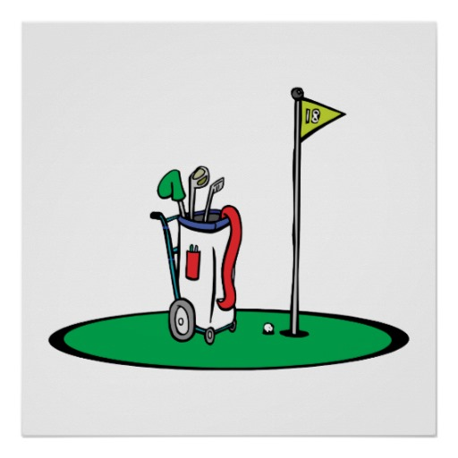
Welcome Golfers : I Hope Its Not Too Late ! , Come In & Close The Door

Welcome to our ‘ ECO - LOO.

We Would Love You To Follow Our Guidelines.

As In Greece ( Remember That When You Were There On Holiday A Few Years Ago ? )

Please, Don’t Put The Toilet Paper / Tissue Down The Loo.

Use The Reciprocal Provided, I Think There’s A Couple Of Them

In Front Of You or Either Side Of You

Please Use These Bins To Put In Your Toilet Paper / Tissues.

OK- Understand

Job Done - Enjoy The Rest Of Your Round.

Goodbye - But Don’t Forget To Sanitize Your Hands.

